Health Care System Using Internet of Things

Vishal mahuli1, Vishwanath Kulkarni2, Anvitha Rao3,Adarsh Raj4

*1 Student VII SEM, B.E, Computer Science. Engg., MSRIT, Bangalore, India*

*2 Student VII SEM, B.E, Computer Science. Engg., MSRIT, Bangalore, India*

*3 Student VII SEM, B.E, Computer Science. Engg., MSRIT, Bangalore, India*

*4 Student VII SEM, B.E, Computer Science. Engg., MSRIT, Bangalore, India*

***Abstract*-With the increase in the number of Internet users over the past decade has made internet a part and parcel of our life , The internet of things with cloud computing is a new trend in managing online data and monitoring them . IOT is one of the latest and emerging Internet technologies which let the network devices sense and collect data around us and share it across the internet where people can utilize and process the data.. health care system using Iot is a system that uses computers to provide an efficient and easy way to monitor the health of a patient remotely and provide immediate assistance when required. It employs the integration of cloud networking, wireless communication, to store the patients’ health details thus keeping the users updated about the patients’ health which can be accessed remotely.**

**In this paper we present a health care system(HCS)using Intel Galileo gen2. In such a system the body sensors in/around the patient gather health information ,which gets stored in the cloud. When there is high variations in body temperature and pulse rate, health care clinic staff are alerted through which they can provide immediate assistance and alert the doctor and provide treatment by referring the catalogue. This system targets aged people who live alone with comparatively good health condition and also people in critical conditions who need constant survillance. This system is designed to be low cost and expandable.**

***Keywords*:** Health care System (HCS), Internet of Things (IoT), local server , Intel Galileo Microcontroller gen2,sensors

**I. Introduction**

**A. *Overview***

We are into the 21st century and are totally surrounded by technology. It’s now part and parcel of our life and imagining life without it seems impossible to most of us. Research and technology field has done a phenomenal job with respect to every field of science. Just as other fields of sciences, Medical sciences have also made a very large leap from where it was earlier before the advancement of science. One important aspect of life which advances in science and technology have impacted is the comfort and ease of solving any daily life problem.

Many systems would be existing in the medical science field for efficient health care of the patients. For effective monitoring of patients, especially the ones who are physically differently abled or are old people who are incapable of performing normal day routines. This system is an attempt to simplify the effective and easy monitoring of the patients especially for old and physically disabled people. Monitoring of such patients has always been a tough as well as important task for the hospital management. For such people, continuous evaluation of their body parameters must be done and also such records should be maintained so as to evaluate the change and variation of the patient’s body behavior towards the disease/virus/infection etc. Such systems should exist which eases the job of monitoring and also solves the ease of handling the reports concerned with all the tests the patients undergo.

The important aspect that we wish to touch with an attempt to develop such system is that we will have a system which will in turn monitor the patient instead of done manually by someone. This system monitors the patient and in case of any intolerable variations, an immediate action is taken i.e…it automatically sends an email as well as text regarding the severity of the patient. This system is an attempt to resolve the issues like manual monitoring of the patient. This system monitors body temperature and pulse rate. This is a very elementary and is a basic monitoring system which can be further modified technologically to monitor other body monitors.

Our system measures the temperature with a wide range of values and similarly pulse rate is measured based on the voltage levels recorded.

**II. Design**

***A.Proposed System Feature***

The proposed system is a distributed health care system, consists of server and sensors. Server controls and monitors the various sensors, and can be easily configured to handle more hardware interface module (sensors). The Intel Galileo Gen2 development board, with built in LAN port , makes the data available all time . Health System can be accessed from the web browser of any local PC in the same LAN using server IP, with appropriate web browser through server real IP (internet IP). LAN is selected to be the network infrastructure that connects server and the sensors. We are creating a local server through xampp in which data is stored using MySQL database. A web interface is created using PHP.

***B. Software design***

***1) Front End Design*:**

* PHP is an HTML-embedded, server-side scripting language designed for web development. PHP stands for Hypertext Preprocessor.PHP is an open source software and it is free to download and use.Allows web developers to create dynamic content that interact with databases. PHP supports various databases like MySQL, Oracle, Sybase, Solid, PostgreSQL, Informix etc.In this project we are using mysql.It consistes of php tags as well as html as html is embedded in php.These tags are used for processing as well as telling how the content has to be delivered.The user can see only the html content where as the php contents are hidden.
* An email that is sent using google’s gmail.

**2**) ***Backend design***

* XAMPP is a [free and open source](https://en.wikipedia.org/wiki/Free_software) [cross-platform](https://en.wikipedia.org/wiki/Cross-platform) [web server](https://en.wikipedia.org/wiki/Web_server) [solution stack](https://en.wikipedia.org/wiki/Solution_stack) package developed by Apache Friends,[]](https://en.wikipedia.org/wiki/XAMPP#cite_note-kaiseidlerinterview-1) consisting mainly [Apache,HTTPServer](https://en.wikipedia.org/wiki/Apache_HTTP_Server" \o "Apache HTTP Server), [MariaDB](https://en.wikipedia.org/wiki/MariaDB" \o "MariaDB) [database](https://en.wikipedia.org/wiki/Database), and [interpreters](https://en.wikipedia.org/wiki/Interpreter_(computing)) for scripts written in the[PHP](https://en.wikipedia.org/wiki/PHP) and [Perl](https://en.wikipedia.org/wiki/Perl) [programming languages](https://en.wikipedia.org/wiki/Programming_language). It is a simple, lightweight Apache distribution that makes it extremely easy for developers to create a local web server for testing purposes . XAMPP has the ability to serve web pages on the [World Wide Web](https://en.wikipedia.org/wiki/World_Wide_Web).
* The Arduino IDE  is the program used to write code, and comes in the form of a downloadable file on the Arduino website. When programming your Arduino board it is important to know what COM port the Arduino is using on your PC.
* The [Boards Manager](https://www.arduino.cc/en/Guide/Cores) included in the standard installation allows to add support for the growing number of new boards based on different cores like Arduino Due, Arduino Zero, Edison, Galileo and so on.

***3) System Design:***

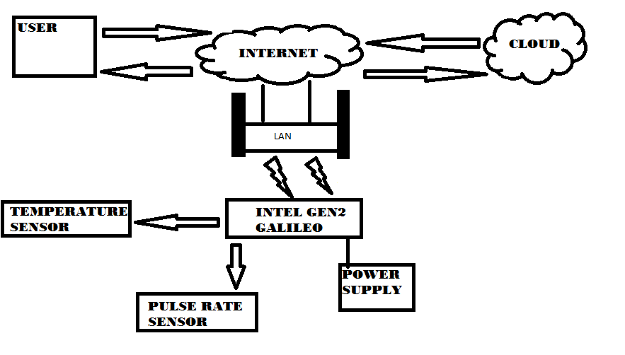

Fig 1.Proposed model of health care system

The proposed model of the health care system is as shown in the figure1. The model consists of different sensors like temperature and pulse sensor. In the proposed model the temperature and pulse rate variations of a person are monitored. Initially the Intel Galileo gen2 connects to the internet through LAN . When the connection is established it will start reading the parameters of sensors like p1, p2 etc. The threshold levels for the required sensors are set as t1, t2 etc. The sensors data are collected and sent to the local server . The data can be analyzed anywhere any time. If the sensor parameters are greater than the threshold level then an email is sent to the corresponding guardian and the health care clinic staff and the required action is taken based on the condition of the patient for the controlling of parameters which have crossed the threshold value. The temperature and the pulse rate are stored on the local server for analysis using mysql. Even under normal conditions the guardian or the doctor can check the patients catalog to see the patients past health conditions which helps them in detecting the problem .The user can also monitor the patients health through the internet via web interface provided.Thus we have continuous monitoring of patients body temperature and pulse , in turn keeping the clinical staff and the guardian updated of the patients health.

**III. Implementation**

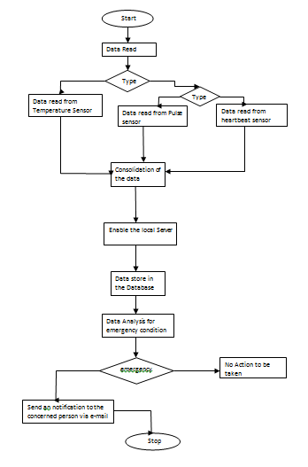

Fig 1.Dataflow diagrams

The sensors are connected to galileo gen2 board along with a LAN wire connected to its port to make the data available across the internet as shown in figure2.The patient is made to touch both the sensors to take the readings.When the connection is established it will start reading the parameters of sensors like p1, p2, p3 etc. The threshold levels for the required sensors are set as t1, t2, t3 etc. The sensor data are read using the arduino IDE using appropriate codes. The data can be analyzed anywhere any time. The data is continuously read thus making it highly reliable .Lan cable is connected to the board to make the data available on the local server.

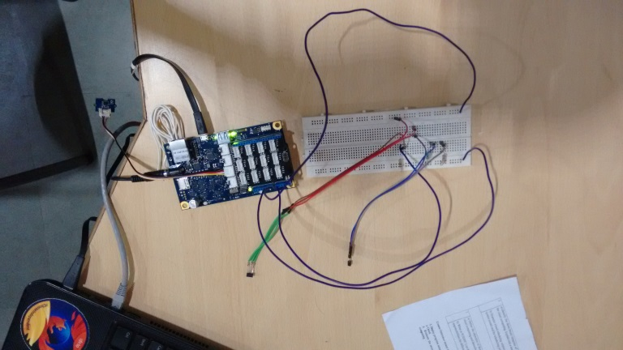

Fig 2.Experimental setup

The data that is read is pushed on to the local server created using xampp for every reading using python codes.The data sent to xampp is stored in MYSQL database. The data is read from the sensor every 10 seconds and sent to the server which is made available in the web interface created using PHP. When the temperature variations or pulse rate variations exceeds the predefined threshold values it sends an email to the guardian using python code and the clinical staff thus making them aware that the patient needs immediate care. The patient’s body temperature and the pulse values can be accessed by the guardian by the web interface provided even under normal health conditions The flow of the project in shown in figure 1.This web interface provides a graphical representation of the data that is read and collected thus keeping them updated about the patient’s health. Thus providing an easy and efficient way to monitor and access the patient’s health condition.

**IV. Testing and Comparison**

Software testing is an investigation conducted to provide stakeholders with information about the quality of the product or service under test. Software testing can also provide an objective, independent view of the software to allow the business to appreciate and understand the risks of software implementation. As a result, software testing typically (but not exclusively) attempts to execute a program or application with the intent of finding software bugs (errors or other defects). The job of testing is an iterative process as when one bug is fixed, it can illuminate other, deeper bugs, or can even create new ones. There are generally four recognized levels of tests: unit testing, integration testing, component interface testing, and system testing.

***A. Unit testing***

Unit testing, also known as component testing .One function might have multiple tests, to catch corner cases or other branches in the code. Unit testing alone cannot verify the functionality of a piece of software, but rather is used to ensure that the building blocks of the software work independently from each other.We tested by running codes for temperature and pulse sensors independently to make sure they work according to the requirements.

**B. Integration testing**

Integration testing is any type of software testing that seeks to verify the interfaces between components against a software design. Integration testing works to expose defects in the interfaces and interaction between integrated components (modules). Progressively larger groups of tested software components corresponding to elements of the architectural design are integrated and tested until the software works as a system.The temperature and pulse sensor codes are merged and the interfacing is done with arduino and tested to make sure they still provide the required output.

**C. System testing**

System testing, or end-to-end testing, tests a completely integrated system to verify that it meets its requirements.

**D. Installation testing**

An installation test assures that the system is installed correctly and working at actual customer's hardware.

**V. Result**

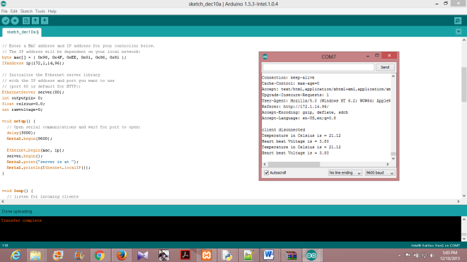

Fig 1.Arduino’s serial monitor displaying sensor data

The figure above shows the arduino ide where the temperature and pulse extraction code are run and the output is seen through serial monitor which can be accessed through backend**.**

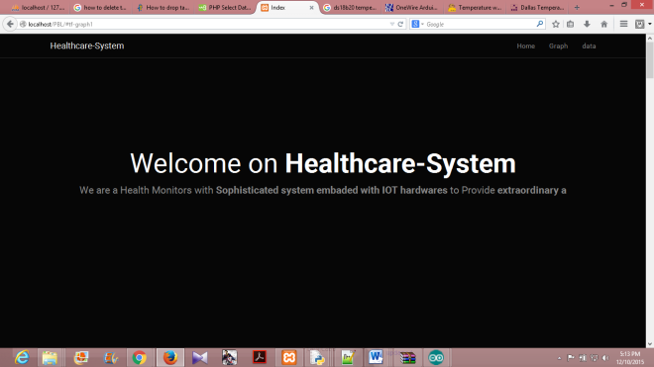

Fig 2.Web server page

After the successful connection to the server, the data of sensor are sent to the web server for monitoring of the system. The figure 2 shows the web server page which will allow us to monitor and controll the system. By entering the assigned IP address in the web browser this web server page will appear. The web server gives the informaton about the temperature in different time. It also gives the status of the health condition under normal conditions,which we can control remotely.

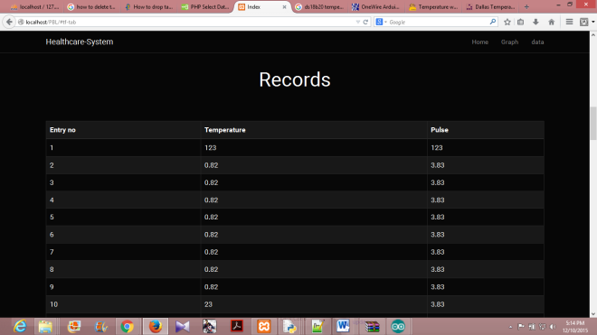

Fig 3.Data in tabular form

All the required data is stored in the MYSQL. The stored data can be analyzed at anytime and anywhere. The figure 3 shows the temperature in degree Celsius stored at different time intervals. And also it shows the state of the pulse value along with the time. All this information is stored in the MYSQL using xampp which is done by running a local server. Which can be checked by the user any time when away from home.The graph shown in the figure 4 gives the analysis of the temperature and pulse at different time and threshold level of the temperature and pulse. By seeing the graph we can come to know the change in the temperature and pulse values. And at what time the temperature was low/ high. We can also know that was temperature and pulse was above the threshold level or not, if was above then at what time thus simultaneously alerting the concerned person for immediate attention to the patient**.**

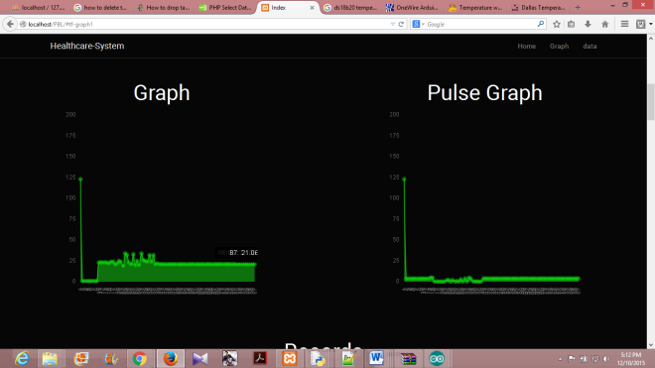

Fig 4. Graph showing the different sensor readings

**VI.SCOPE**

Our system is the first step towards the effective health monitoring and care systems. We have developed the system with temperature and pulse rate sensors. These sensors detect the body temperature variations and pulse beat respectively and is continuously recorded. These records maintained can be very useful for the patient’s medical history and can be analysed to see any specific patterns. Collection of such records can also help in analysing by general medical researchers on which diseases or virus infections trends. In case of any emergency such as heavy variation in body temperature or improper pulse rate, an email will be sent to the concerned doctor and the guardian whose email address will be mentioned for patient’s admission form. This part ensures that if at all any irregularities occur with patient, it will be dealt immediately and can be provided with the necessary help.

**VII.FUTURE WORK**

Using this system as framework, the system can be expanded to include various other sensors which could include body movement sensors, pressure sensors etc..and storing it onto the cloud. By storing onto cloud data can be accessed from anywhere and large volumes of data can be easily stored. This will further help in even more effective monitoring of patients. This kind of a system with respective changes can be implemented in the hospitals for disabled people ,in nursing homes or at old age homes will serve the people better and in an easy way.

**VIII. Conclusion**

The healthcare monitoring system is successful in its objective of providing an efficient and compelling way of health care of patients. The basic aim to reduce the manual effort put in such task and to maintain a separate catalogue for patients. This will help the doctors for recognizing any trends and making further decisions on medication and treatment for that patient. Such systems can help in reduction in also maintaining the reports for the patients.

**XI. Acknowledgement**

First and foremost we would like to thank Mrs. Sowmya B. J. (Assistant Professor),Department of Computer Science and Engineering, M. S. Ramaiah Institute of technology, Bangalore, who was also our supervisor, for their consistent guidance on each and every step of our project and also our HOD Dr. K.G.Srinivasa(Professor). Without their push and motivation, this project would have not been completed. Their continuous support and help made this project feasible. Without her support we would not have been able to excel in our project. Lastly, we would like to thanks all our teammates for believing in each other and our capabilities.

**X. References**

 [1] *Python Software [US]*,[online] Available: <https://pypi.python.org/pypi>

[2]GalileoGen2,[online]Available:https://www.arduino.cc/en/Guide/IntelGalileoGen2

**[3]**  Claire Rowland, Elizabeth Goodman, Martin Charlier, Ann Light & Alfred Lui “[Designing Connected Products](http://www.designingconnectedproducts.com/)”,

[4] [online]Available: [http://enterpriseiotbook.com](http://enterpriseiotbook.com/)

[5] [online]Available: https://software.intel.com/en-us/iot/library/galileo-getting-started

[6**]**  Madni, A.M., "Smart Configurable Wireless Sensors and Actuators for System of Systems (SoS) Applications". Keynote Address, Proceedings, IEEE SMC Intl. Conf. on System of Sytems Engineering, Los Angeles, April 2006.

# [7].Von Lubitz, D. and N. Wickramasinghe, 2006 "Healthcare and Technology: The Doctrine of Networkcentric Helahtcare," Intl. J Electronic Healthcare(IJEH), vol. 4, pp.322-344.

# [8] Introducing Intel Galileo as a development platform of smart sensor: Evolution, opportunities and challenges,School of Engineering and Advanced Technology, Massey University, Palmerston North, New Zealand [Ghayvat, Hemant](http://ieeexplore.ieee.org/search/searchresult.jsp?searchWithin=%22Authors%22:.QT.Ghayvat,%20Hemant.QT.&newsearch=true) ; [Mukhopadhyay, S.C.](http://ieeexplore.ieee.org/search/searchresult.jsp?searchWithin=%22Authors%22:.QT.Mukhopadhyay,%20S.C..QT.&newsearch=true)

[9] D. Guinard, "A Web of Things Application Architecture - Integrating the Real-World into the Web," Ph.D., ETH Zurich, 2011.

[10] Introducing the intel galileo development board. [Online]. Available: http://www.intel.com/content/www/us/en/do-it-yourself/galileomaker- quark-board.html

[11] N. Tsuruta, Y. Shigeta, S. Maeda, S. Takahashi and T. Morimoto  "A Dialogue System for Home Health care(In Japanese)",  *Correspondences on Human Interface*,  vol. 4,  no. 4,  2002

[12] online] Available: <https://docs.python.org/3/library/email-examples.html>

[13] Albert Sweigart”Automate the boring stuff with python”, February 25, 2015

[14][online]Available:<https://software.intel.com/enus/blogs/2015/05/29/grove-starter-kit-with-intel-galileo-gen-2-getting-started-0>

[15] [online]Available: https://en.wikipedia.org/wiki/Intel_Galileo